11.Create a dataframe of ten rows, four columns with random values. Convert some values to nan values. Write a Pandas program which will highlight the nan values.

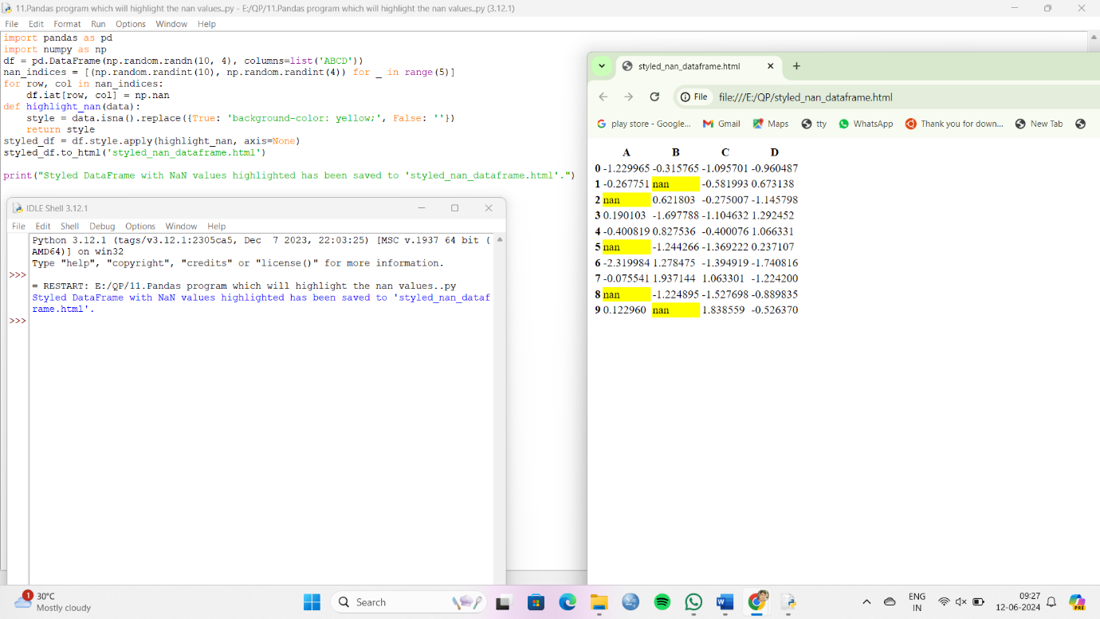

12.Create a dataframe of ten rows, four columns with random values. Write a Pandas program to set dataframe background Color black and font color yellow.

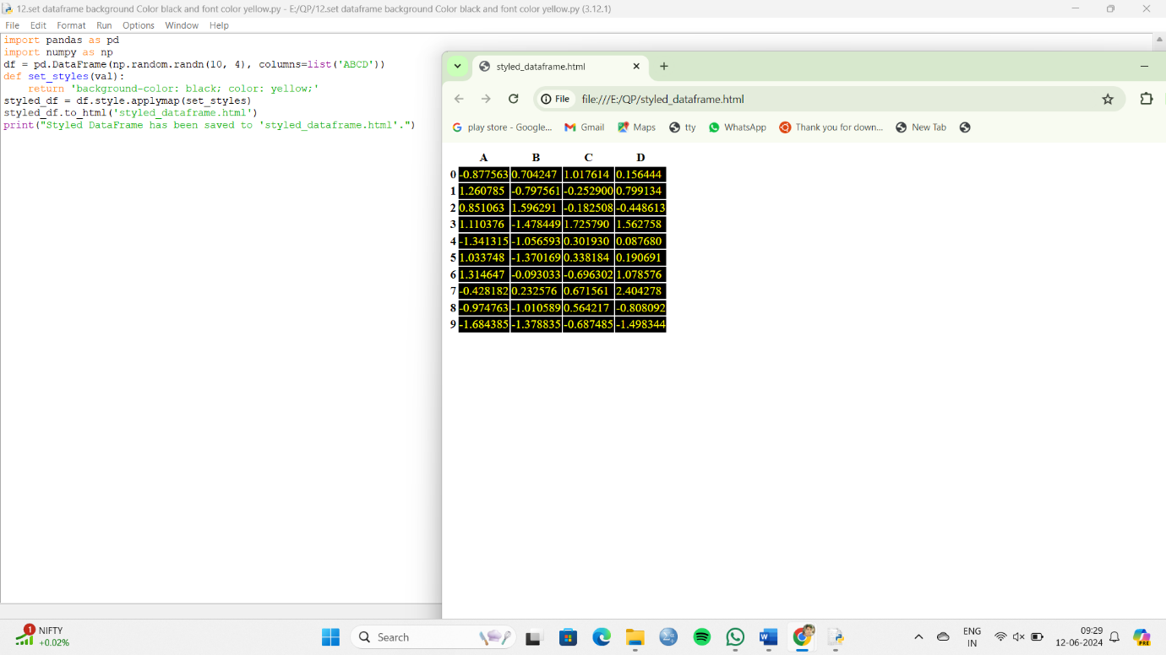

13.Write a Pandas program to detect missing values of a given DataFrame. Display True or False.

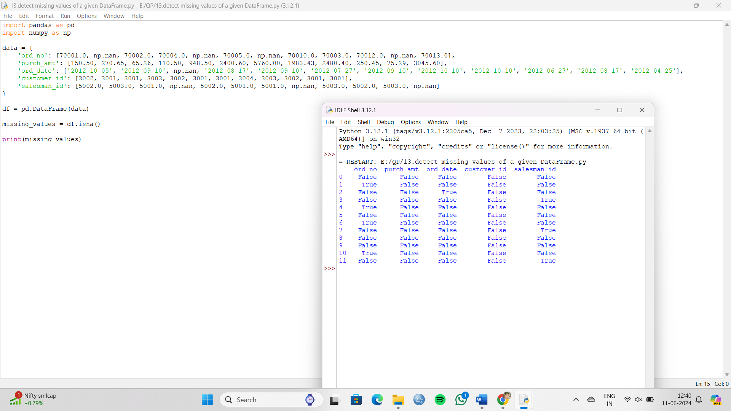

14. Write a Pandas program to find and replace the missing values in a given DataFrame which do not have any valuable information.

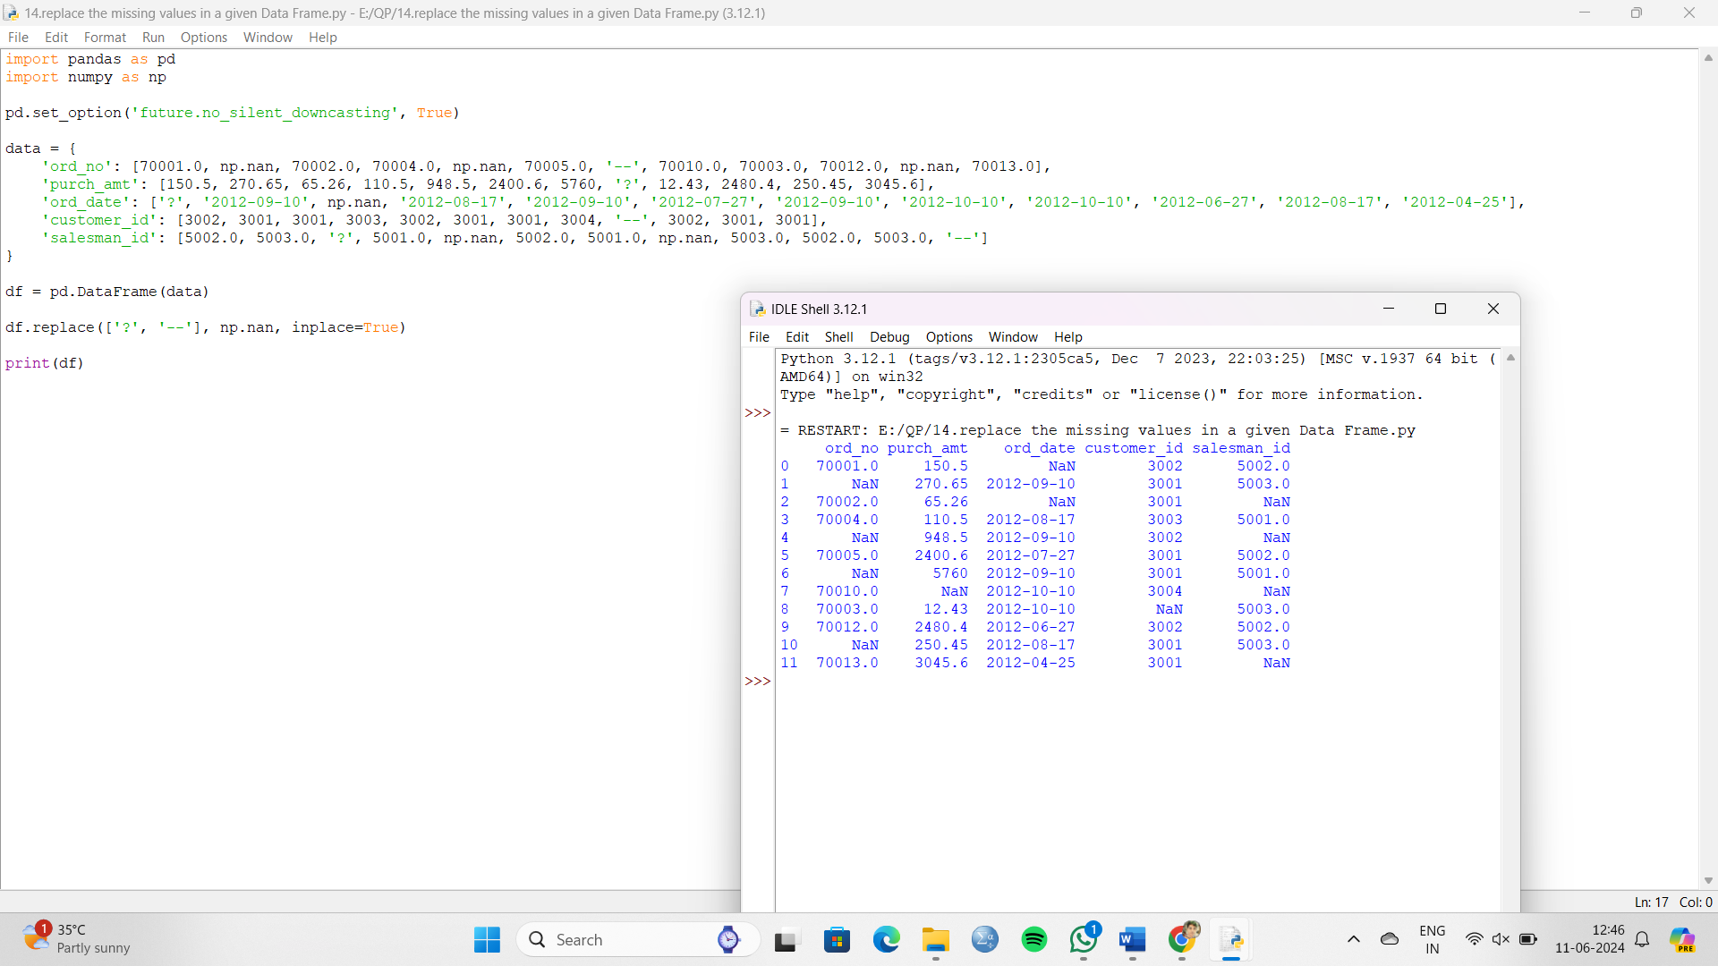

15. Write a Pandas program to keep the rows with at least 2 NaN values in a given DataFrame.

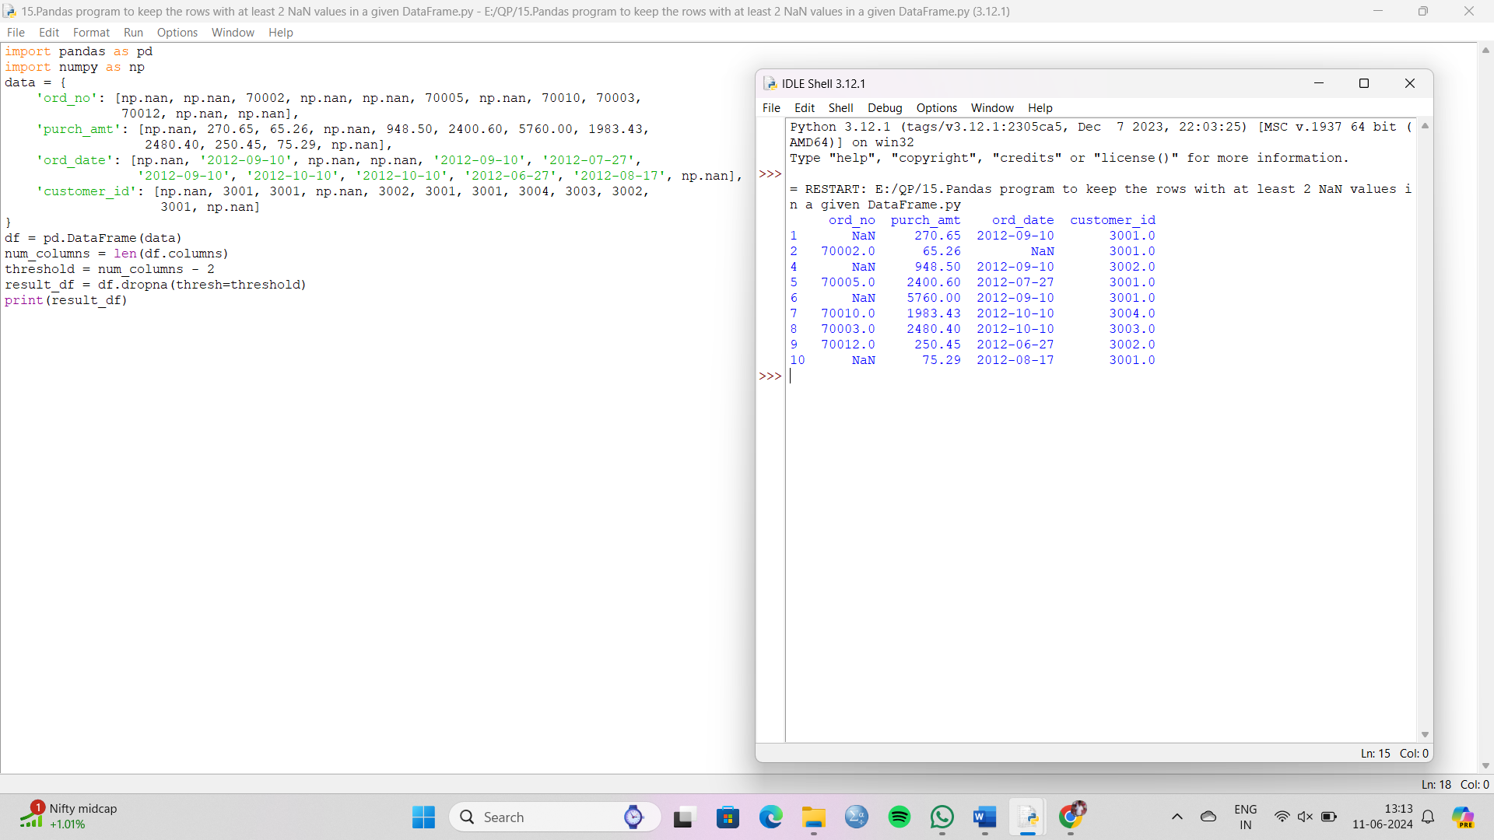

16. Write a Pandas program to split the following dataframe into groups based on school code. Also check the type of GroupBy object.

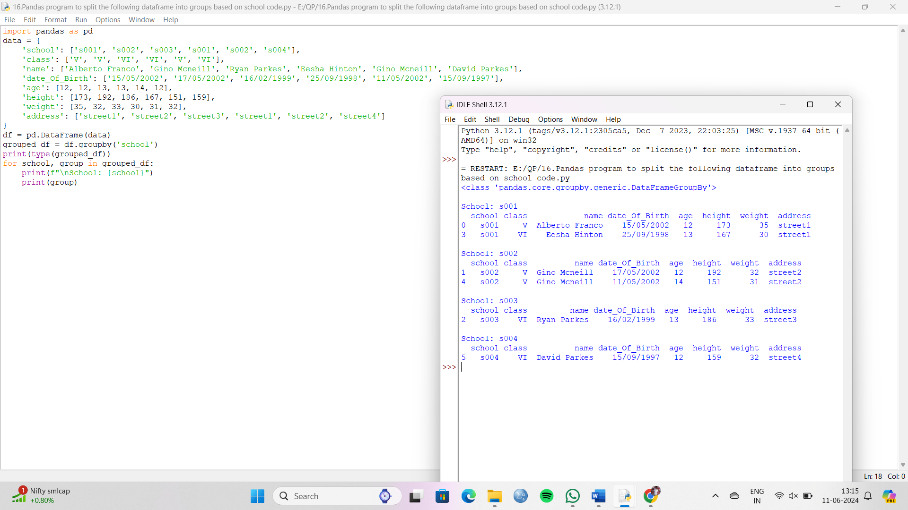

17. Write a Pandas program to split the following dataframe by school code and get mean, min, and max value of age for each school.

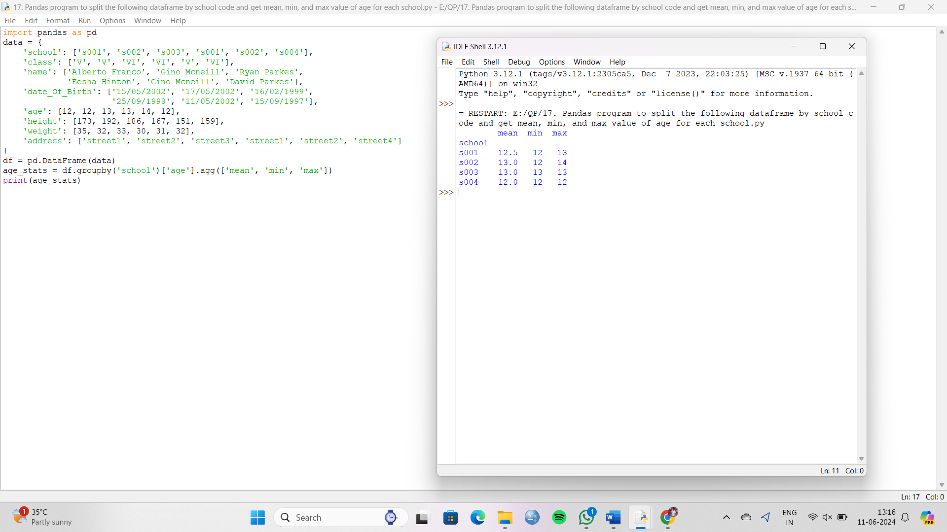

18. Write a Pandas program to split the following given dataframe into groups based on school code and class.

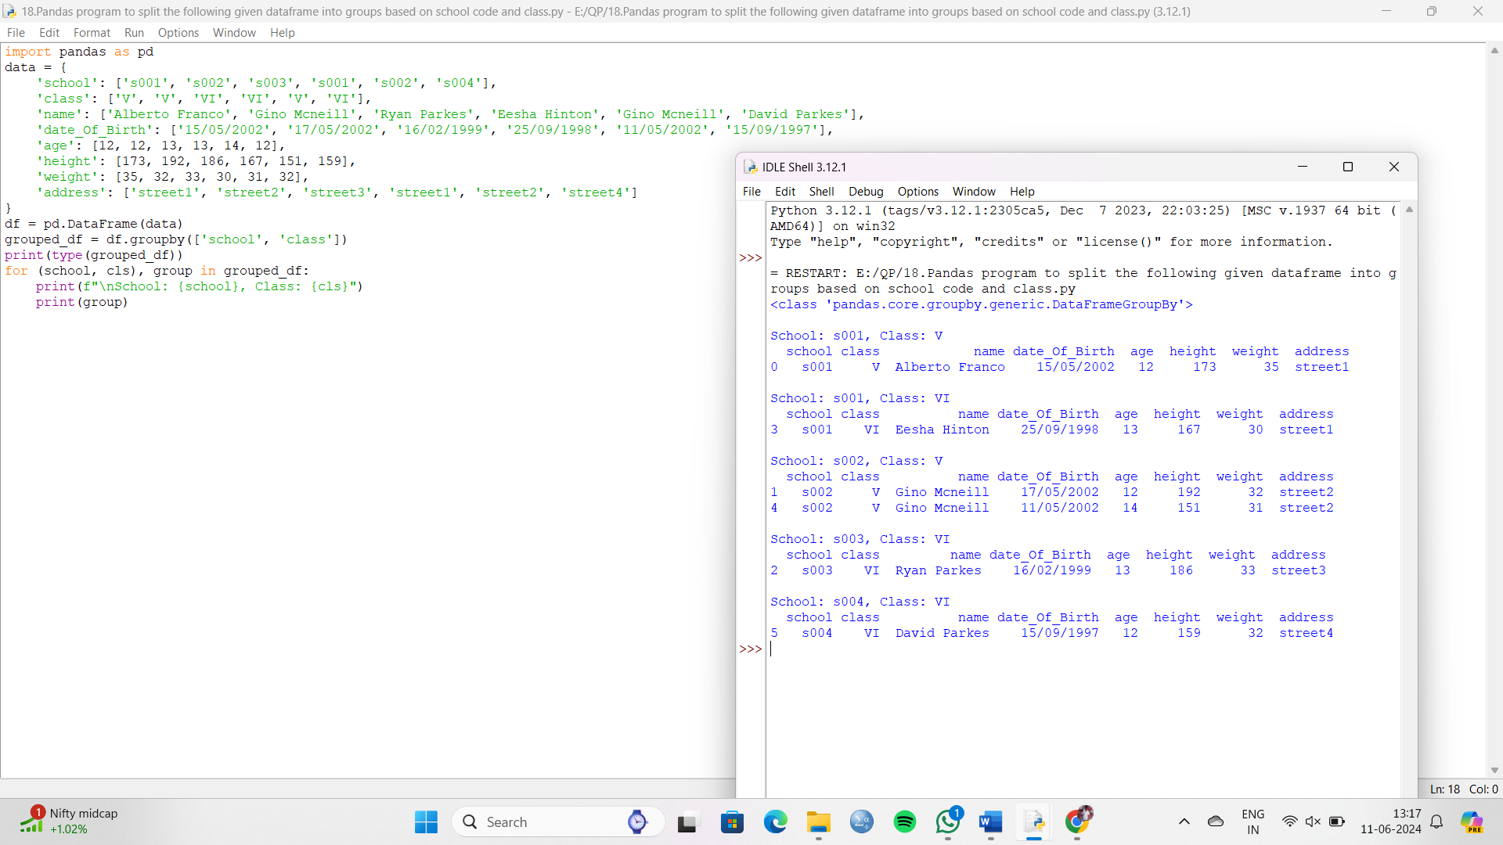

19. Write a Pandas program to display the dimensions or shape of the World alcohol consumption dataset. Also extract the column names from the dataset.

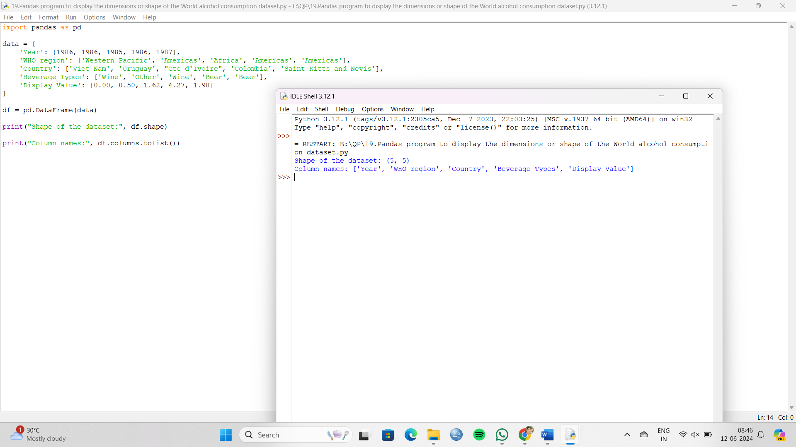

20. Write a Pandas program to find the index of a given substring of a DataFrame column.

